W5 PRACTICE
STATELESS WIDGETS

 Learning objectives
- Manipulate Column layout with stretch alignment
- Use Icons, Image and Card widgets
- Use Enums with attributes to specify a data model
- Create re-usable StatelessWidget
- Manage required and optional widget properties

 No AI tools allowed to solve this practice

How to submit?
- Push your final code on your GitHub repository
- Then attach the GitHub path to the MS Team assignment and turn it in

 Before practice, to be prepared!
Read the following documentation to be ready for this practice:

https://www.classcentral.com/classroom/youtube-flutter-tutorial-for-beginners-45851/60c82bddaba3e
https://www.classcentral.com/classroom/youtube-flutter-tutorial-for-beginners-45851/60c82bddaba15
https://www.youtube.com/watch?v=GPoRjSjd1cI
https://api.flutter.dev/flutter/material/Card-class.html
https://www.classcentral.com/classroom/youtube-flutter-tutorial-for-beginners-45851/60c82bddaba0a
https://api.flutter.dev/flutter/widgets/Image-class.html

EX 1 – The hobbies
In this exercise, you need to arrange hobbies cards vertically, each containing a hobby with an icon and text.
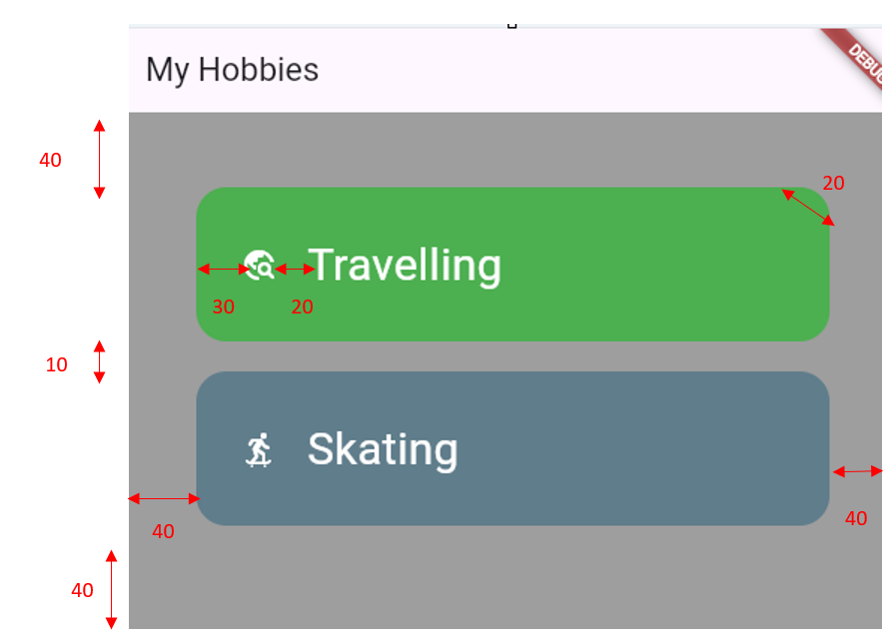

This exercise has 2 parts:
- Part 1: create a single hobby card
- Part 2: extract the card into a stateless widget

PART 1 – Build the UI
Start by create a single hobby card

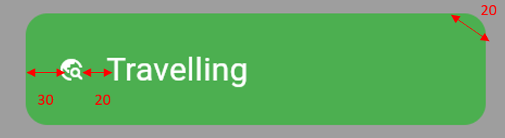

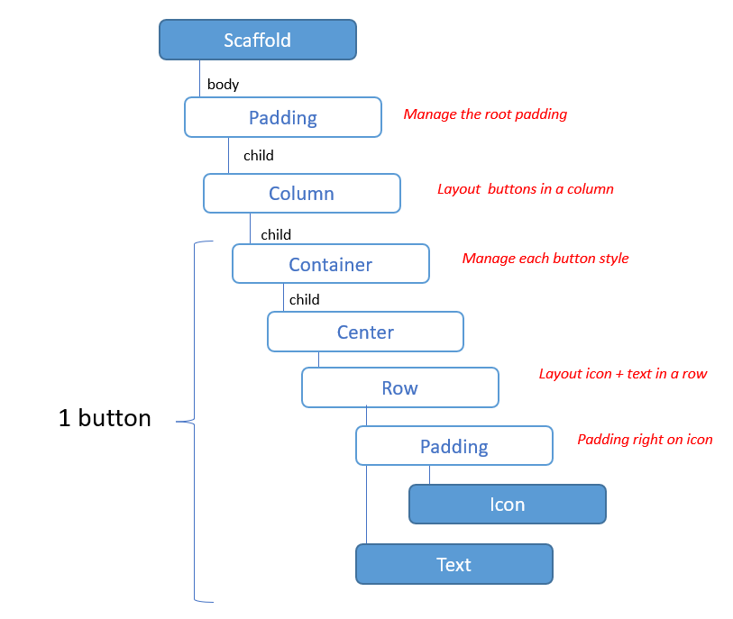

- We use CrossAxisAlignment.stretch on Column, so that the children to take up the entire width of the parent. More about Colum here

What is the difference between crossAxisAlignment and mainAxisAlignment in Column widget? Try it out to understand.

- We use predefined icons from the Icons class. More about icons here

- The button radius is performed using a BoxDecoration on the container. More about box decoration here

PART 2 – Create a HobbyCard widget
Extract the hobby card into a stateless widget called HobbyCard that takes the following parameters:

- The hobby title (String, required)
- The hobby icon (IconData, required)
- The card background color (Color, optional, default value = BLUE)

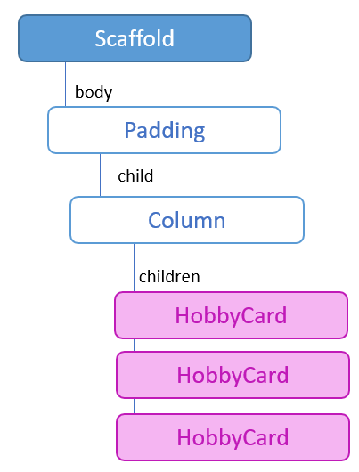

EX 2– The buttons
In this exercise, you need to build a Custom Button

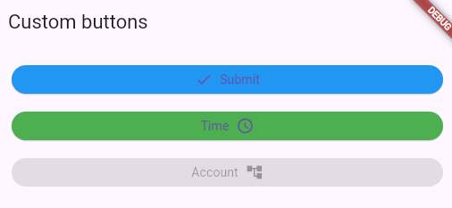

The button can have 3 types. Each type has a specific color:
Button type | Color
Primary | Blue
Secondary | green
Disabled | grey

Note: we recommend managing this requirement with a dedicated enum!

The button icon can be either before or after the button label:

Note: we recommend managing this requirement with a dedicated enum!

The custom button must be a stateless widget called CustomButton that takes the following parameters:

- The button label (String, required)
- The button icon (IconData, required)
- The icon position (left or right, optional, by default left)
- The button type (primary, secondary, disabled, optional, by primary)

EX 3 – The products
In this exercise, you need to arrange product cards vertically, each containing a product image, title and description.

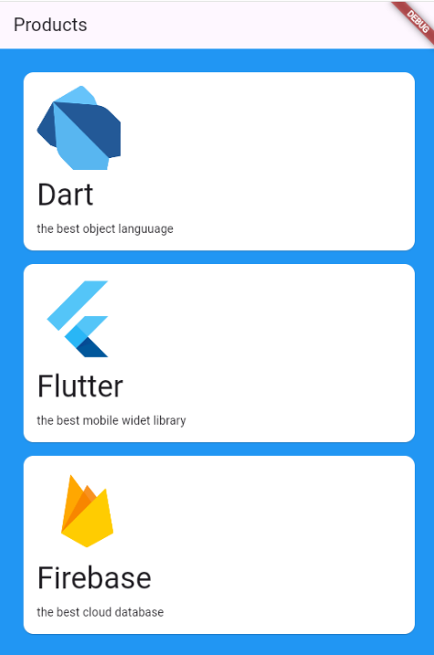

This exercise has 3 parts:
- Part 1: create a single hobby card
- Part 2: create a Enum gathering each product information
- Part 2: extract the card into a stateless widget

PART 1 – Build the UI
Start by create a single card

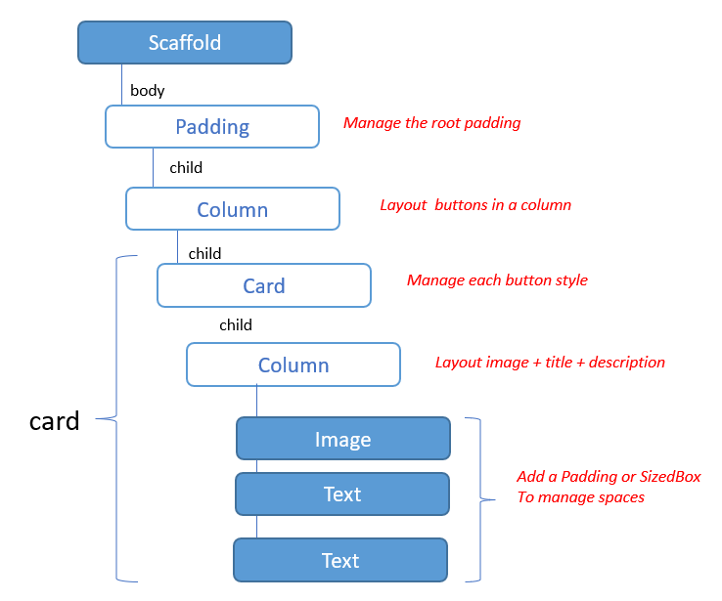

- We use Card widget, to style the card. More information about card here

- We use Image widget, to display images. More information here and here.
  - We will store images in asset folder
  - The 3 images are provided in the ZIP folder

PART 2 – Create a Enum product
To store our product, we are using enum.TO learn more about enum: here

Enums are a special kind of class used to represent fixed number of constant values.
Why enum? Because our products are always the same and will not change over time

Enum can also have attributes and constructors, and this is what we are doing right now.

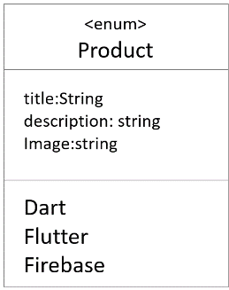

- Start to create a Product enum, following the above UML.
- The enum has 3 values: dart, flutter, firebase.

PART 3 – Create a Product widget
Extract the card into a stateless widget called ProductCard that takes the following parameters (named):

- The product (type: Product, required)

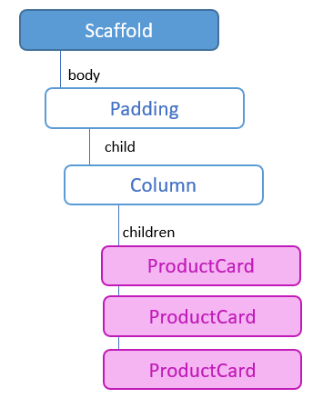

EX 4 – The weather Forecast
Recreate the given weather app mockup or create your own weather app!

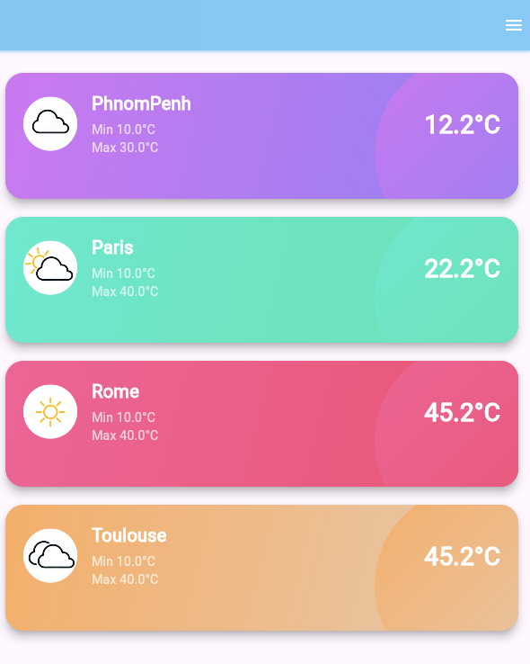

✅ Mandatory parts

- Each card represents a city weather
- Cards must be rounded with gradients and shadow (you will need the PhysicalModel widget)
- Card must contain the min, max, current temperature of the city and a CircleAvatar with the weather type
- Ensure good layout alignment and spacing using Rows/Columns.

🌟 Optional parts (to explore)

- Decorative oval on the right side (you will need the Stack widget)
- Display multiple cards in a scrollable view (you will need the ListView widget)

💭 Hint topics

PhysicalModel
https://api.flutter.dev/flutter/widgets/PhysicalModel-class.html

Stack
https://api.flutter.dev/flutter/widgets/Stack-class.html

CircleAvatar
https://api.flutter.dev/flutter/material/CircleAvatar-class.html

Positioned
https://api.flutter.dev/flutter/widgets/Positioned-class.html

💭 Do you need weather images?

You can download the image ZIP file here.

You will then need to put image on /assets folder and update the pub spec file.
More information here and here.

